**Column Layout**

Block element has a tendency to eat up the width of a page.

How to create columns which are side by side like this?

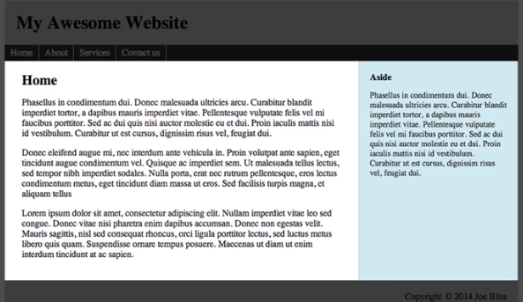

<div id=”wrapper”>

<main> </main>

<aside> </aside>

</div>

** Float main element left, float aside element right. <aside> is used for supplemental information, it does not automatically shift the content to the side!

** If there are more than one column, we float the columns all left, or all right.

*** Professional Developers rarely use IDs to because of their specificity.

*** CSS classes gives you the ability to reuse style.

*** However, IDs are used in Javascript. This process is known as DOM manipulation.